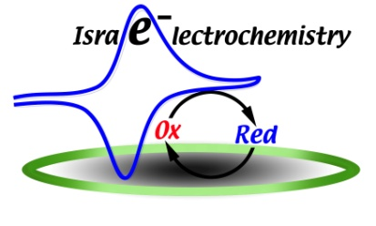
Israelectrochemistry 2014 Exhibition Registration Form

Please fill in all the details IN BLOCK LETTERS and send the form by
E-mail or fax to:
israelectrochemistry2014@gmail.com or fax no. +973-3-6422649

Title: Professor Doctor Mr. Mrs. Ms.

First & Middle Name: _____________________ Family Name: ___________________________
Company/organization: __________________________________________________________
Department:_____________________________________________________________________
Mobile Telephone no.: ________________ Work Telephone no.:___________________________
E-mail:________________________________________________

Exhibition booth includes 2 full registrations, a table and 2 chairs, admission to both oral and poster sessions, refreshments and lunch. Table size: approx. 2.00 meter x 0.80 meter

Exhibition registration fee: 1200 NIS.
The registration should be made before 31.8.2012.

PAYMENT METHOD
Payment will be made by Paycheck to the Technion-Israel Institute of Technology.
The payment should be made in advance.
Payment in advance should be sent to:
Prof. Yair Ein-Eli
Department of materials Engineering
Technion-Israel Institute of Technology
Haifa 3200003

